**PYTHON PROJECT**

**TECHNICAL REPORT ON WEB SCRAPPING AND WEB DEVELOPMENT**

Done by:

Nishigandha Shirish Kulkarni

Sneha Bangalore Nanjundeswar



**GOAL:**

The main goal of the project is to do web scrapping of a massive data set (The website used in our project is <https://www.basketball-reference.com/> ) to get list of all the basket-ball players along with their detailed information and images and to save the output in csv and json formats by using the modules Urllib, Requests, BeautifulSoap, Scrapy and Selelium.

The next goal of the project is web development using Flask, SqlAlchemy to list, search, update and delete the information of the player which is stored in the database.

**DESIGN:**

* The file requirements.txt contains all the requirements to run the project.
* The python file Scrapper.py contains the backend code and is written to scrap the website and store the data into the database named mydb.db.
* Once the python file called app.py is run by the user the app will start and the website can be opened using localhost.
* The file home.html under templates has the font end code. The file players.html is used to design the page where each player’s information is displayed and update.html is used to update each player’s information.

**USER GUIDE:**

Please Run the following command by going to the path where the scrapper.py exists and then press enter.

**Command 1:** pip install -r requirements.txt

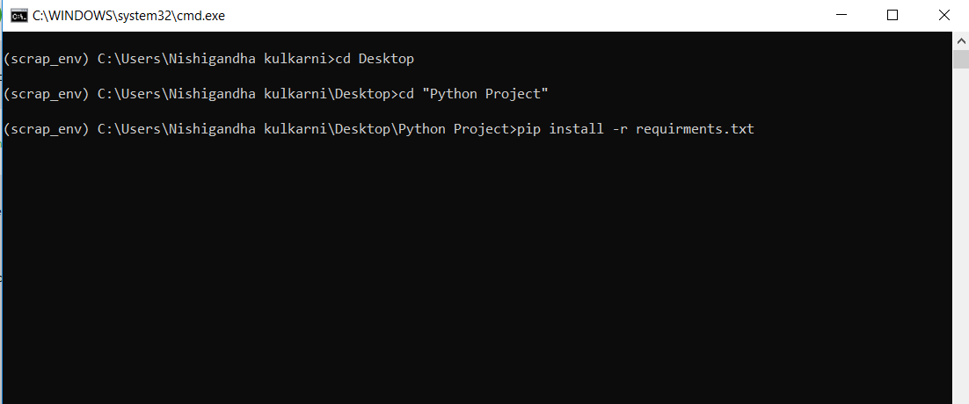

All the requirements to run the project will be installed.

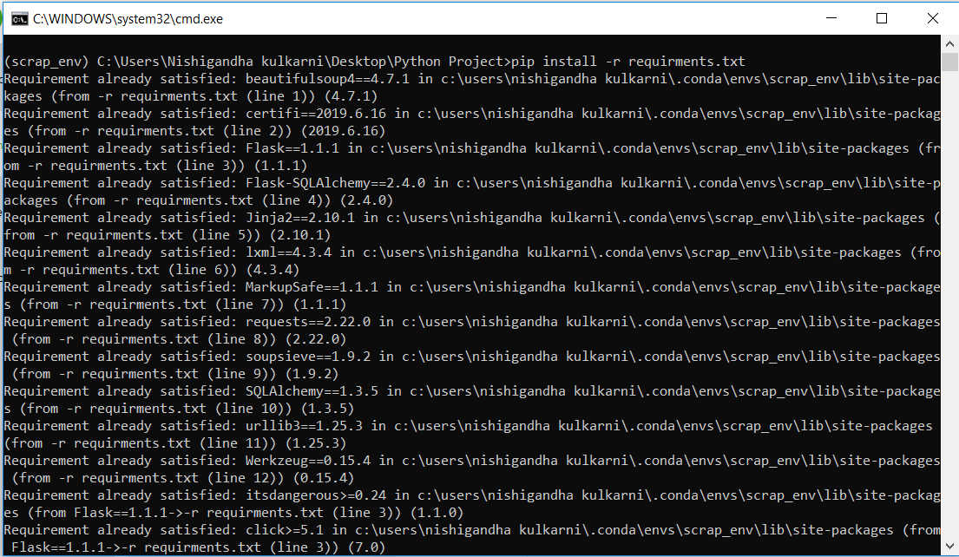

**Command 2:** python scrapper.py

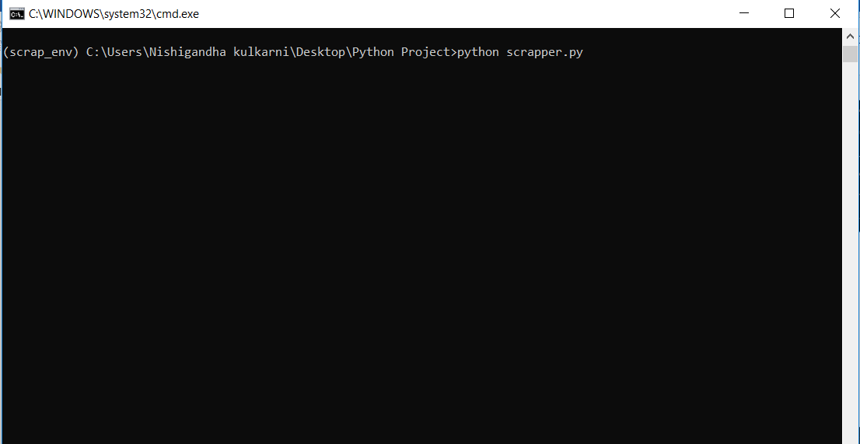

This will scrap all the data from the website as shown below:

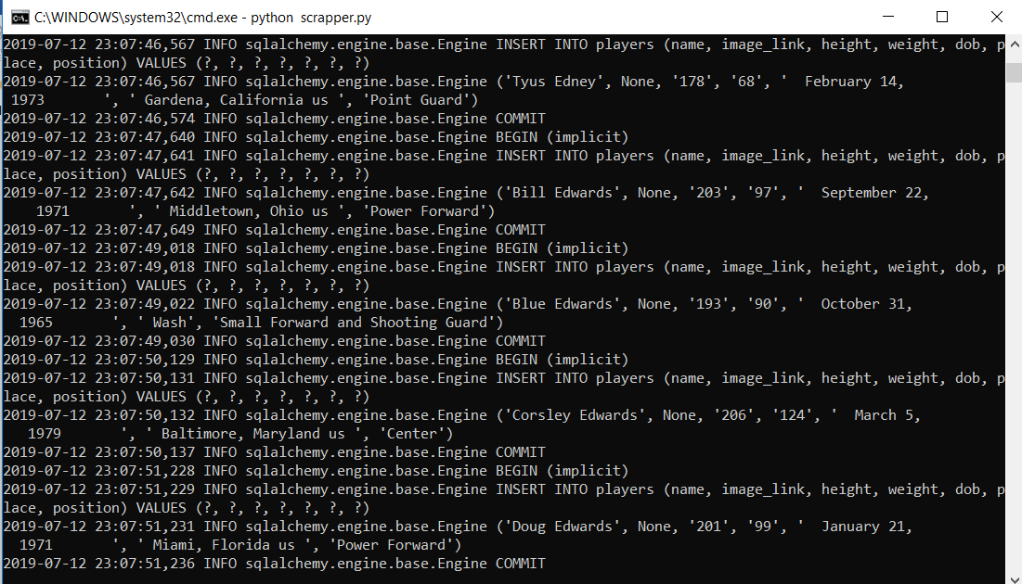

**Command 3:** python app.py

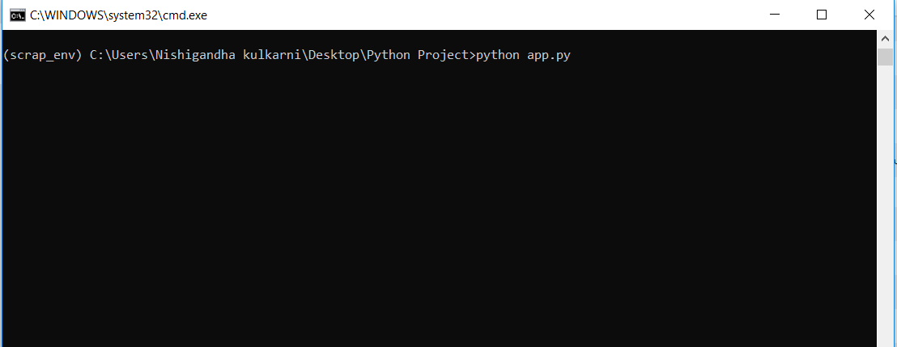

The server will start running on http:localhost:5000

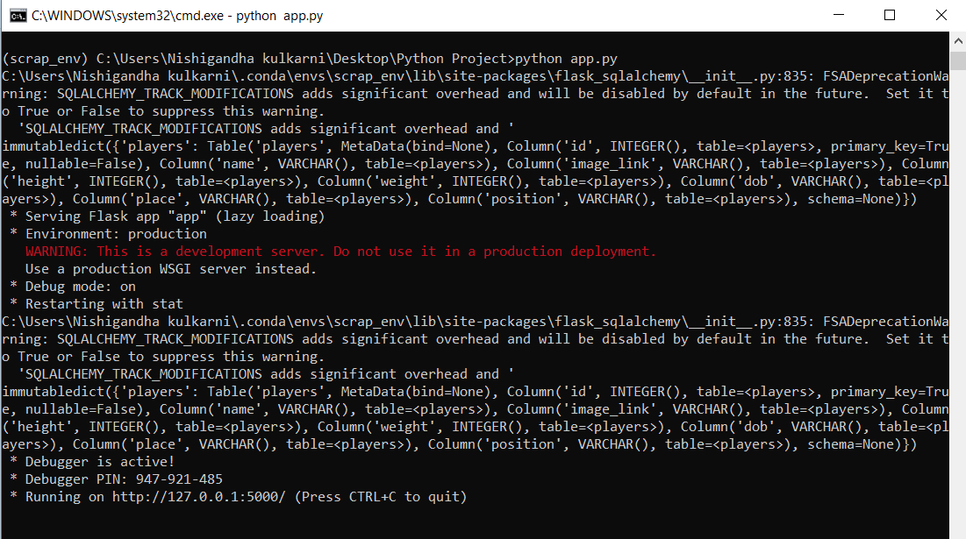

Now please open the website on http:localhost:5000 as shown in the screenshot below:

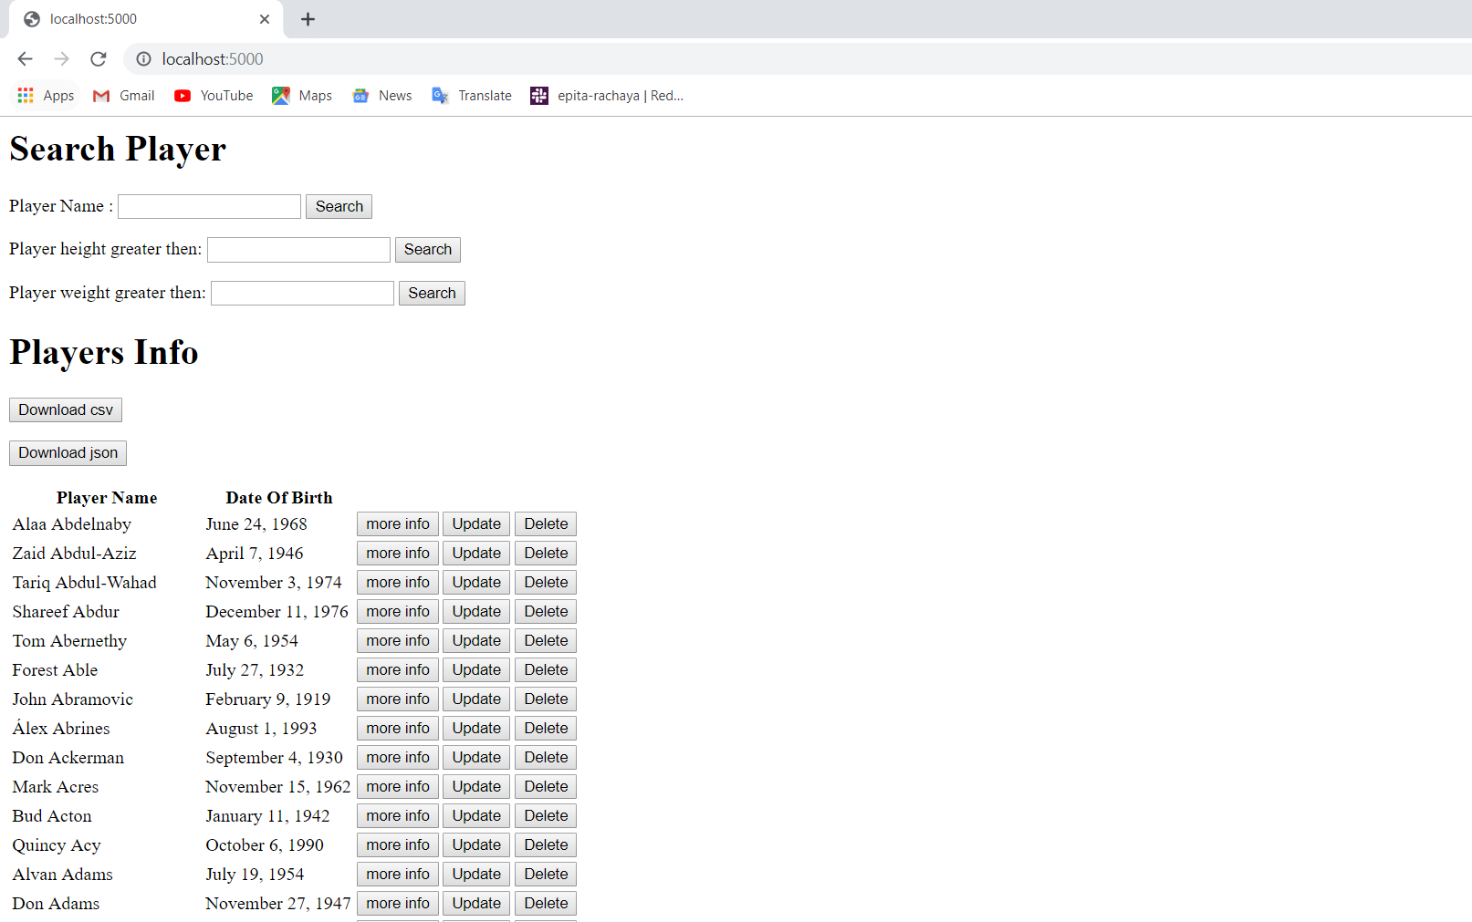

* To Search a player:

To Search a Player please Type the player’s name in the text box as shown below

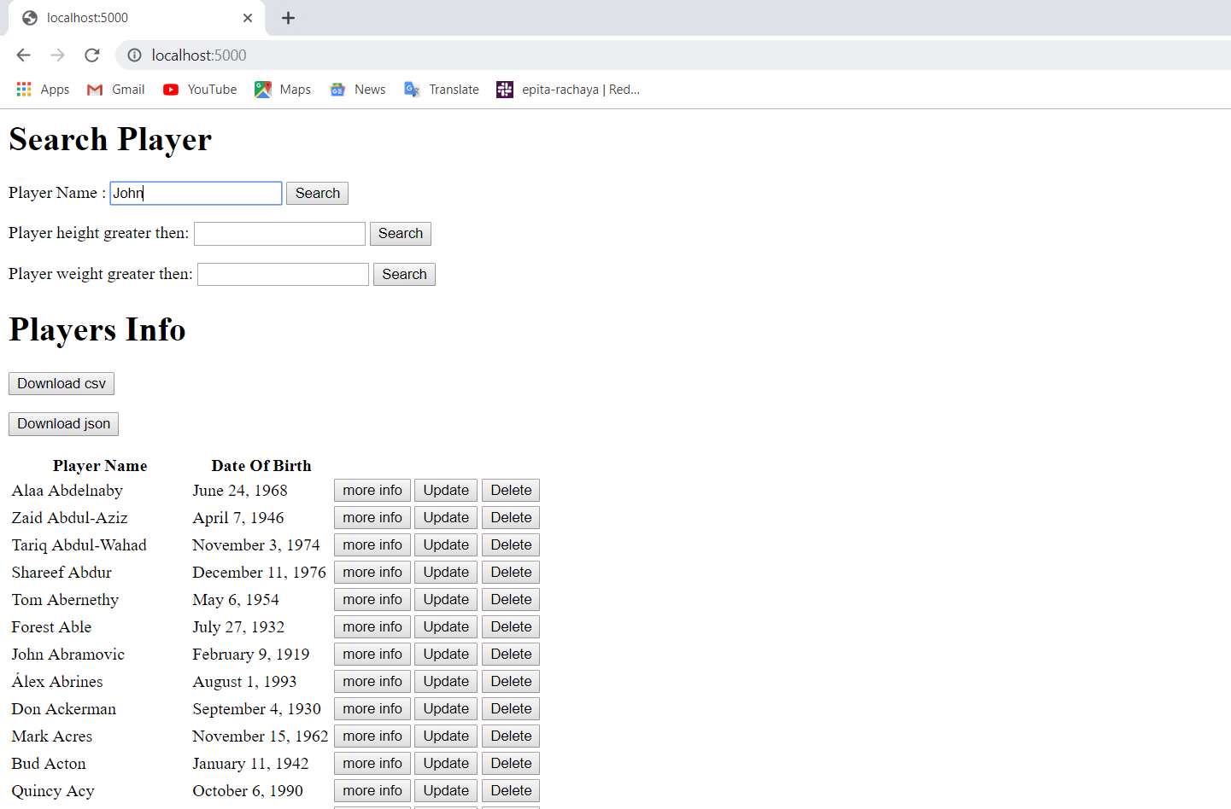

Please click on the Search button

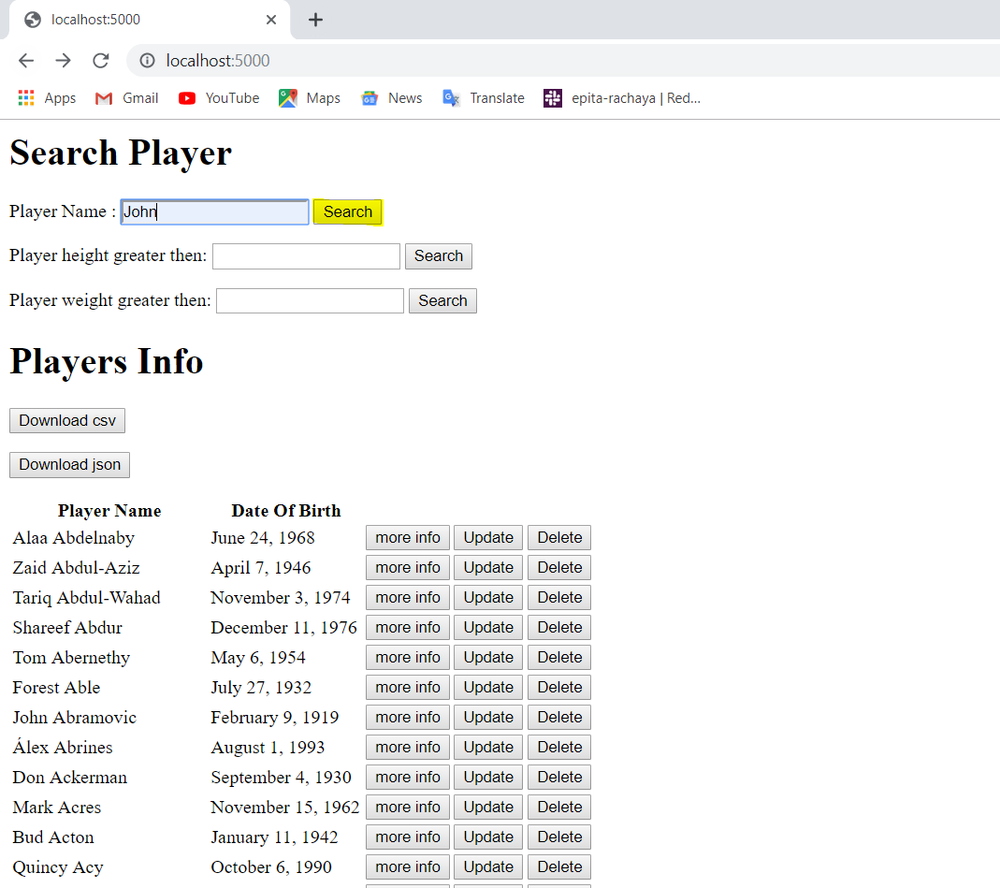

As we can see in the screenshot below all the players with John will get displayed.

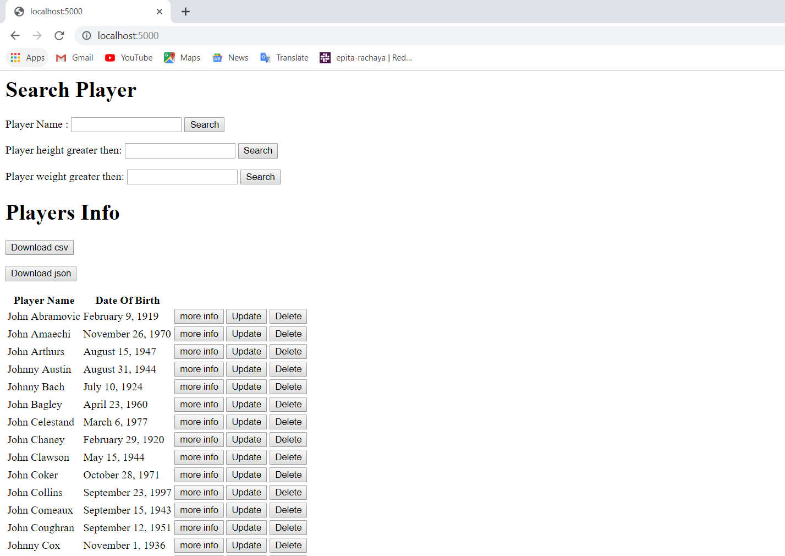

Similarly we can Search for players according to their height and weight.

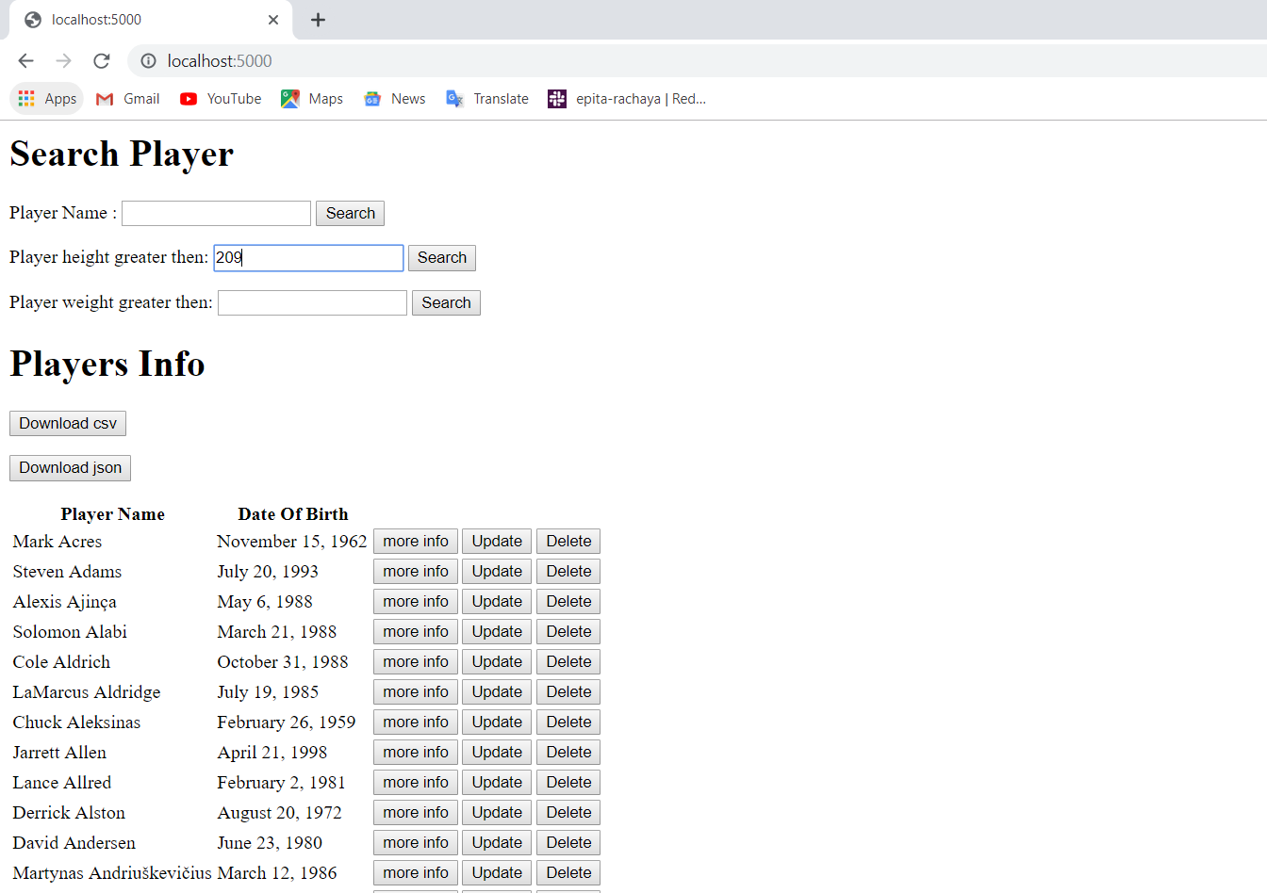

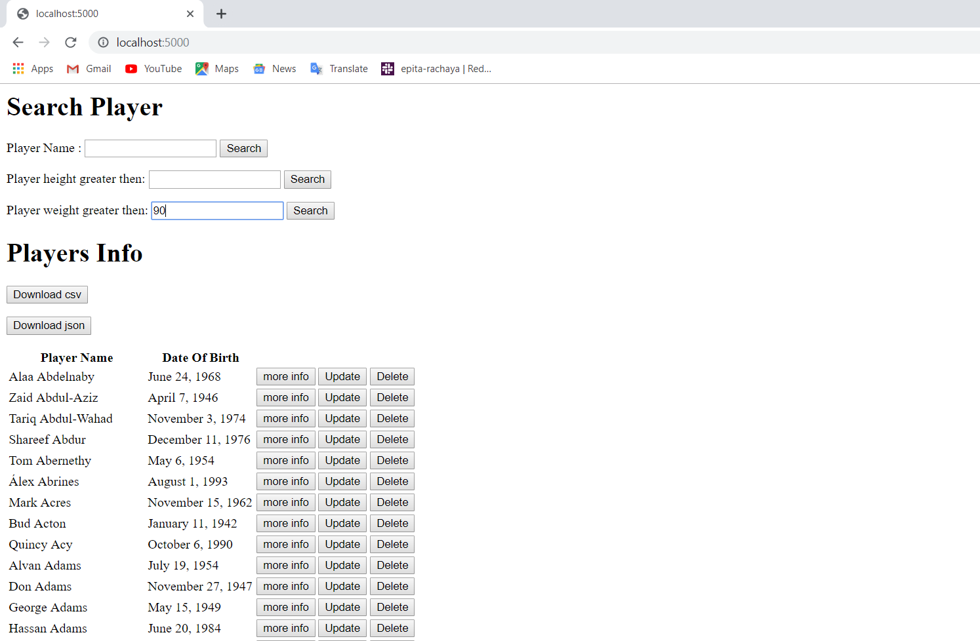

* To update a player’s information:

To update a player’s information, click on the Update Button next to the player’s name

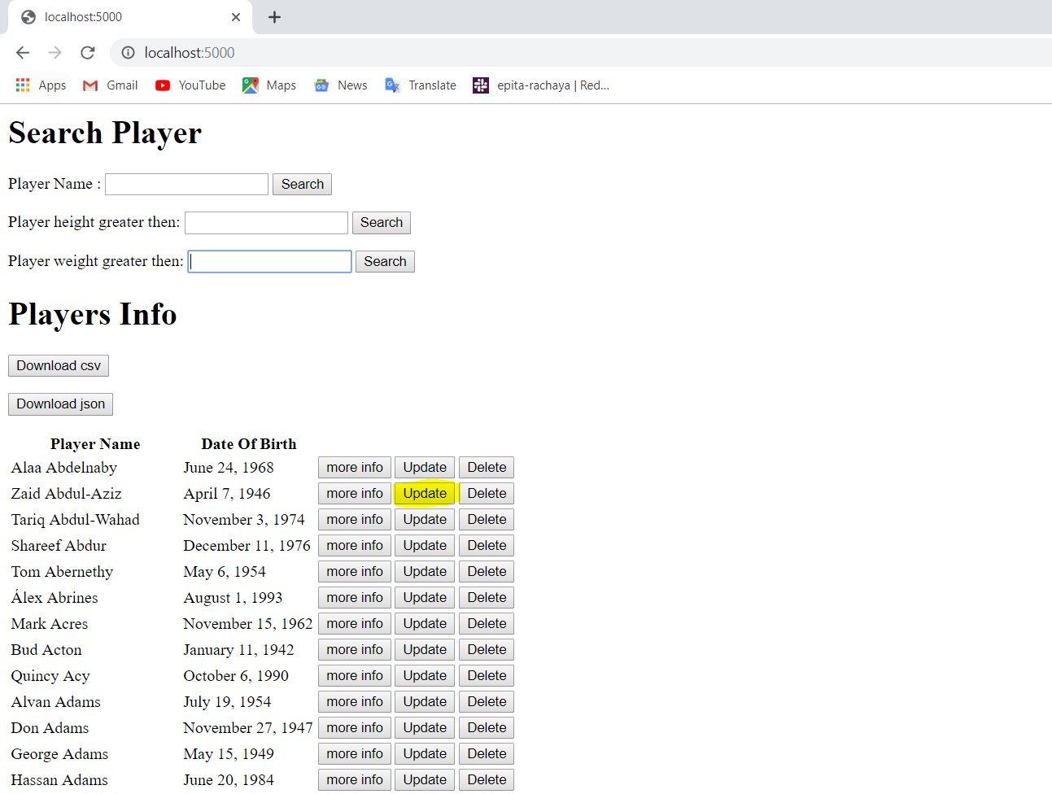

Now change the information which you want to update and click on the update button.

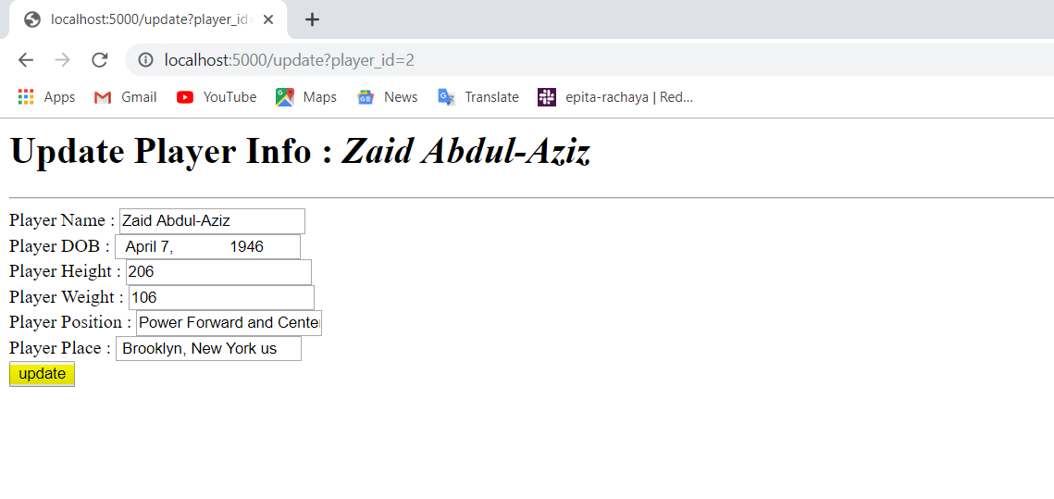

* To Delete a player:

To Delete a player’s information, click on the Delete Button next to the player’s name and his information will be deleted.

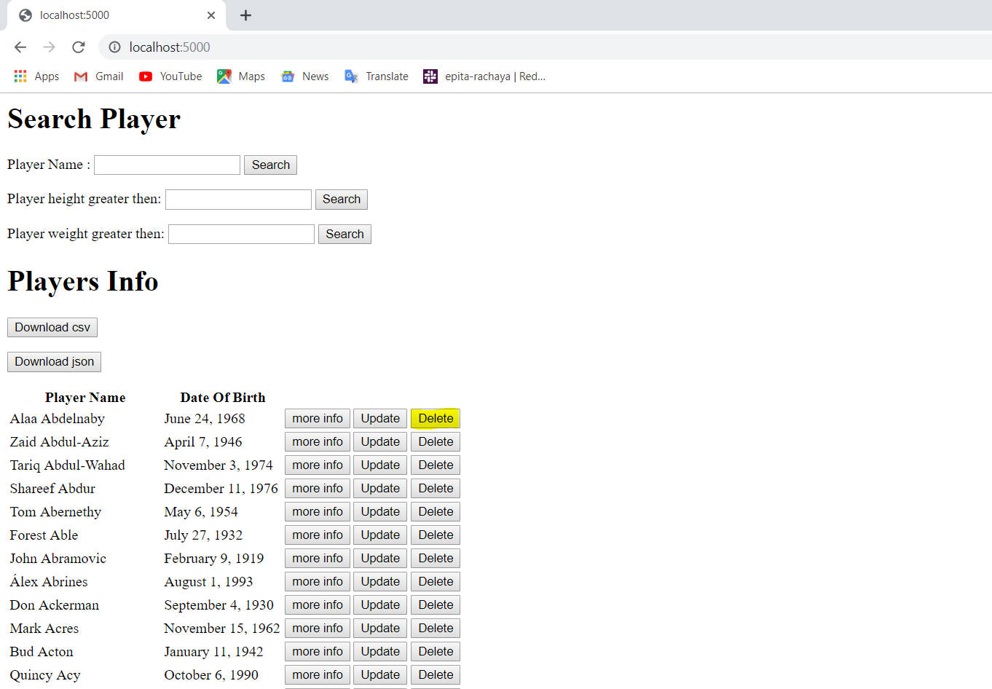

* To view detailed information about a player:

To view detailed information about a player’s information, click on the More info Button next to the player’s name and his information will be displayed along with the player’s image if the image exists.

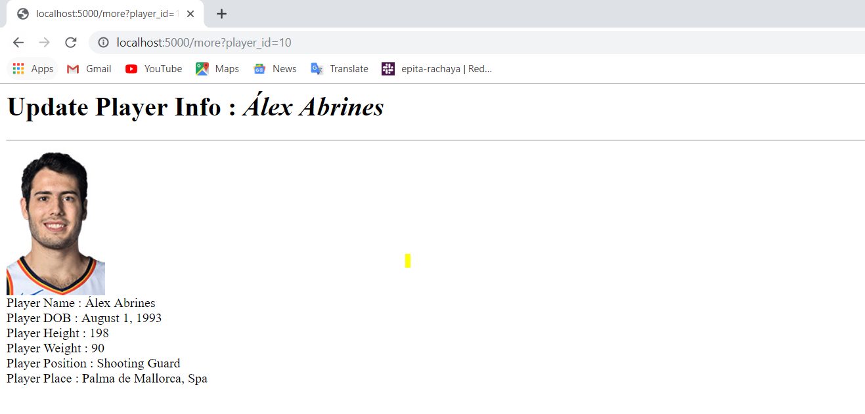

If the image of the player does not exist then no image will be displayed, only the information of the player is diaplayed.

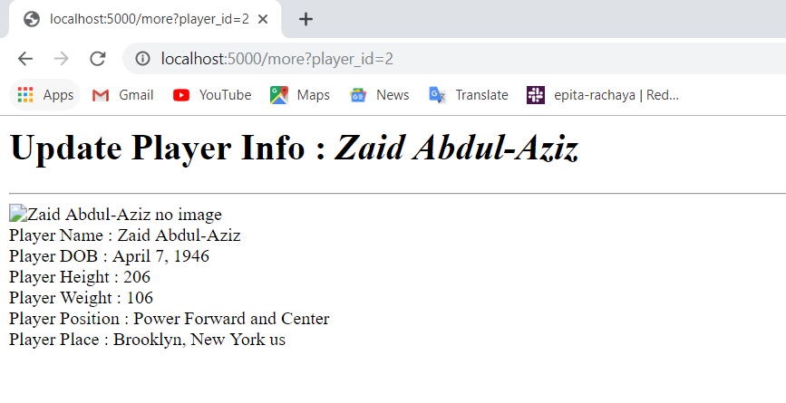

To Download a CSV file please click on the Download CSV button as shown below and the CSV file will be downloaded.

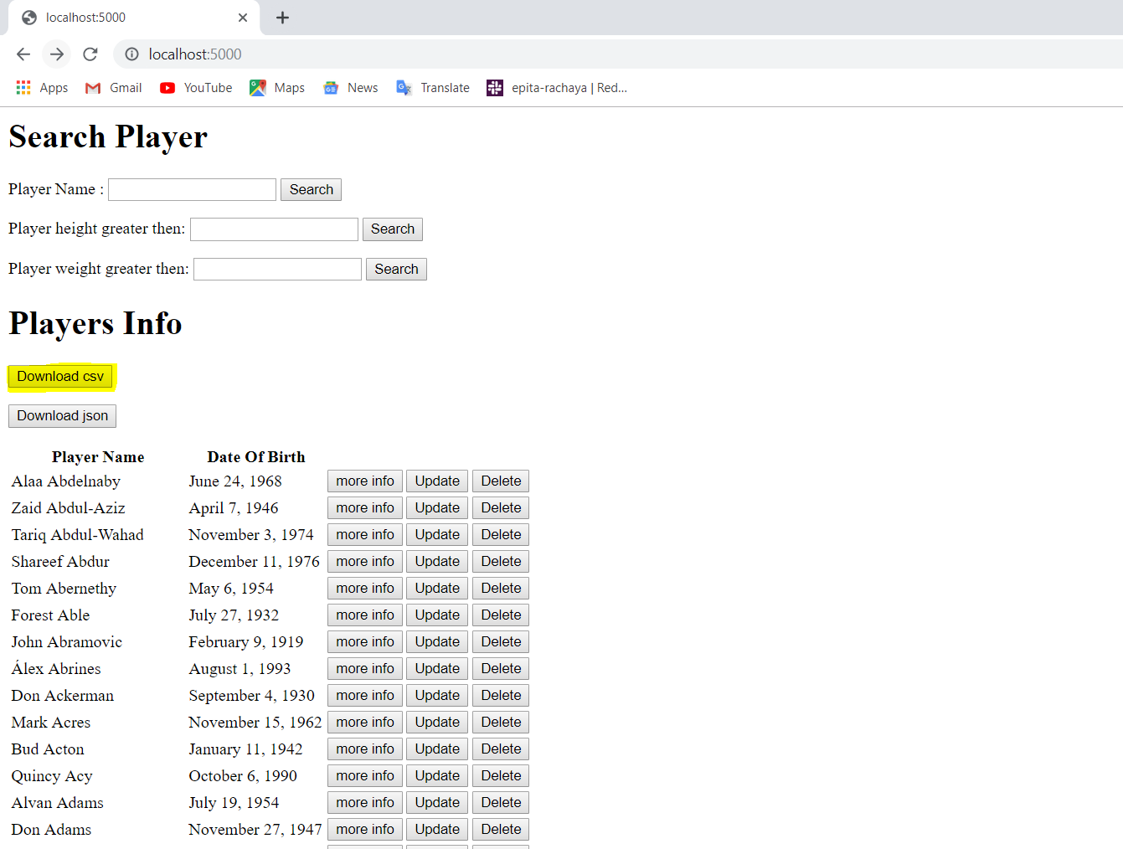

To Download a json file please click on the Download json button as shown below and the json file will be downloaded.

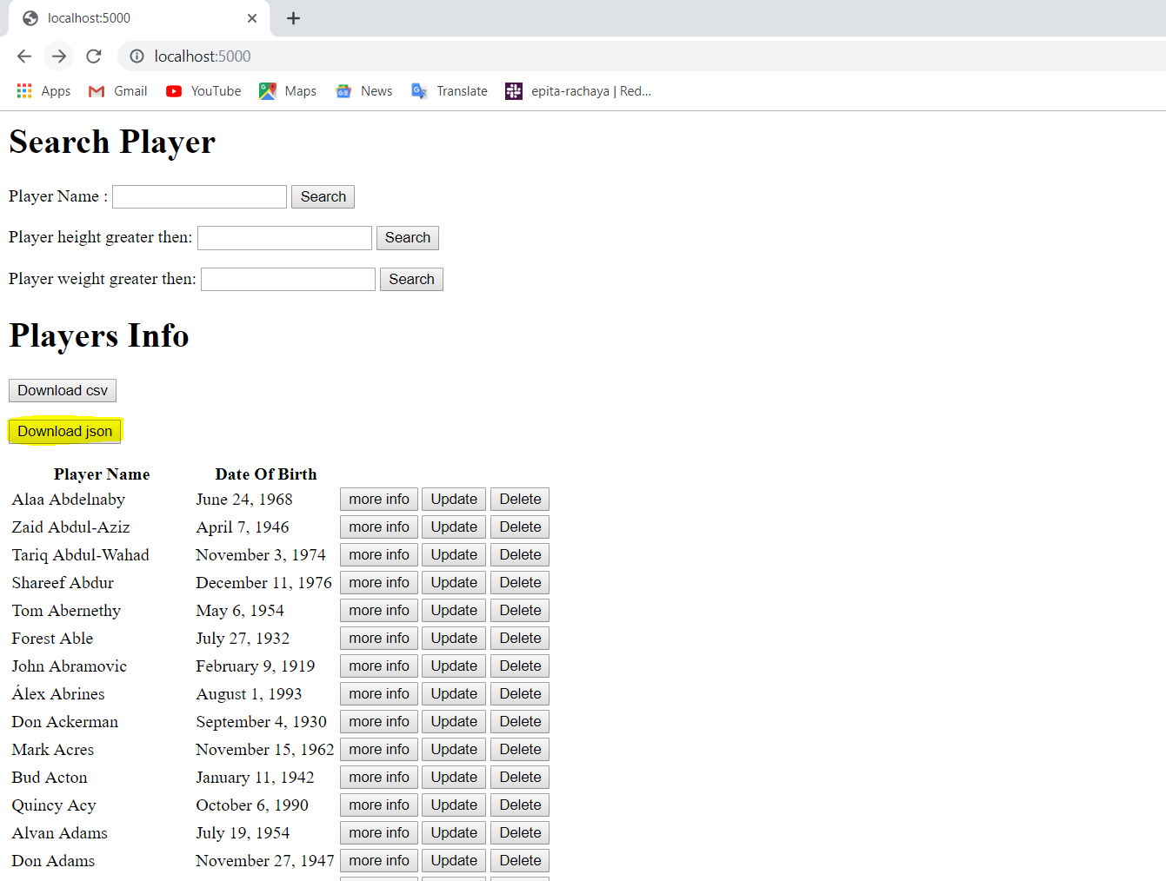

The limit of players getting displayed is 50

